

Mail Server

data structure project

Ahmed Ashraf Abdel Aziz Basha (2).

karim ibrahim mustafa (32).

mahmoud abu elenein (48).

# Description

* This Program provides you with a service seems looks like the one in g-mail.
* You can use the features of the program for the first time by signing up, after that you can access your account by logging in.

# Features

* In this program you can send messages with text contents or attached files.
* You can also deactivate your account if you want.
* You can also delete any message or filter the message in your inbox by the subject or the sender.
* You can sort the messages by their priority or by date (Default).

# Design overview

## First there is splash form for loading Then there are 7 forms

• Signupdemo: That includes the data from the user to make account for him • Logindemo: To allow the user to get into his email.

• Inbox: that shows the messages of the user and any user can delete any email to move it into his trash.

• Sent: That shows the messages that are sent by the user.

• Trash: that shows the messages that are deleted by the user.

• Compose: That allow the user to send any mail to another user include attachments.

• Readmessages: That read the message that the user select from inbox, sent or trash all forms include links to another forms and there is a deactivate button that allow the user to deactivate his account and there is sign-out button to let user get in the program with another account.

Data structures

* Single: linked list to store attachments or emails.
* myStack: stack to implement quick sort.
* PriorityQueue: priority queue to store the mail receivers.
* File: to create a new file or directory.
* int: used in iterations and type of the priority of mail.
* long: used in sort operation.
* boolean: used as a flag.

Description of important function

* signin(String email, String password): Sign in to the application.
* signup(IContact contact): Create new account.
* setViewingOptions(IFolder folder, IFilter filter, ISort sort): apply the sort and search parameters.
* deleteEmails(ILinkedList mails): delete mails (send them to trash).
* compose(IMail email): send a new mail.
* getDate(): get the current time.
* getMails(String mail): get the mail of name “mail”.
* moveEmails(ILinkedList mails, IFolder des): move mails to another folder.
* deactivate(String email): deactivate the email of name “email”.
* deleteDir(File dir): delete the contents of a folder.

User manual

Once the user open the program he will see the shown :

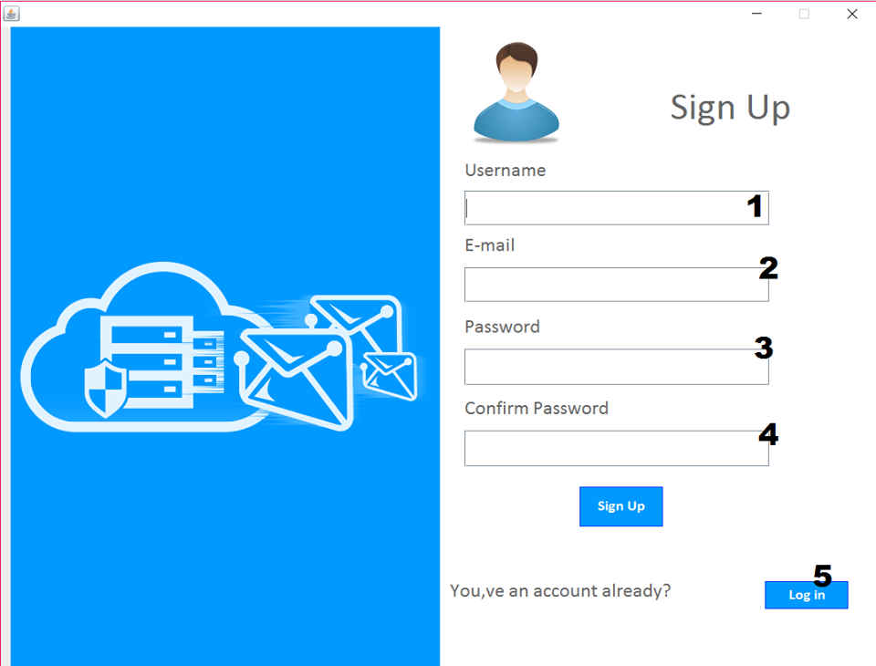

If the user did not have an account yet.

1. User inserts his user name.
2. User inserts his e-mail.
3. User inserts his password.
4. User confirms his password.
5. If he already had an account he logs in.

When the user chose to log in he will see the shown:

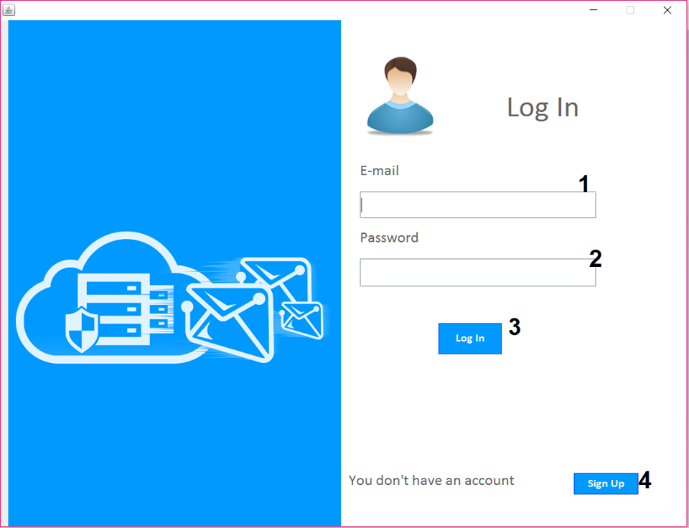

1. User inserts his user e-mail.
2. User inserts his password.
3. He can access his account now.
4. If the user did not have an account yet, he must sign up.

Once the user do that he can use the features of the program.

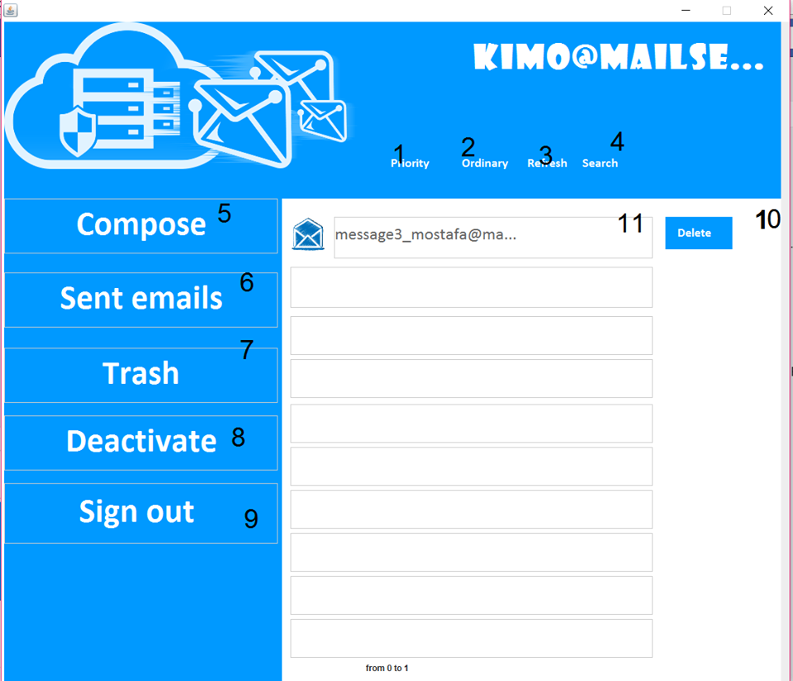

1. To order the messages by priority.
2. To order the messages by date.
3. To refresh.
4. To search for any message.
5. To send a new message.
6. To open sent emails.
7. To open trash (deleted emails).
8. To deactivate the account.
9. To sign out.

To send messages user presses compose, then he will see the shown:

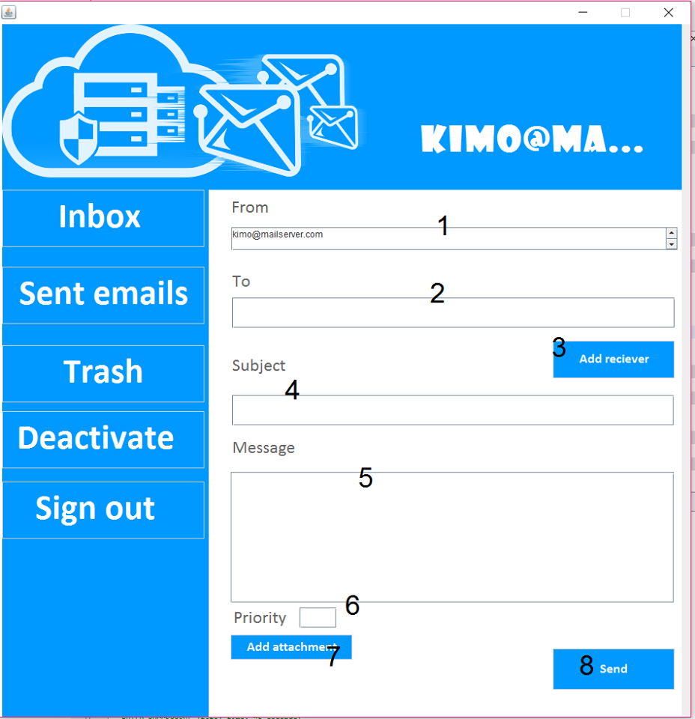

1. Email of the user.
2. The receivers (user can send the same message to many other users).
3. User presses it to add receivers.
4. User adds the subject of the message.
5. User writes the text content.
6. User sets the priority of the message.
7. User attaches any file to his message.
8. Finally, user sends the message.

If user wants to filter the messages by subject or sender.

